

**MIDDLE EAST TECHNICAL UNIVERSITY**

**DEPARTMENT OF ELECTRICAL AND ELECTRONICS ENGINEERING**

**EE463 – Term Project: AC to DC Motor Drive**

**Simulation Report**

***Group Power Quality***

*Alper Çakıroğlu*

*2276772*

*Mustafa Mert Sarıkaya*

*2094381*

*Fatih Serdar Sağlam*

*2481828*

**TABLE OF CONTENTS**

**ABSTRACT** **3**

**INTRODUCTION & SPECIFICATIONS** **3**

**TOPOLOGY SELECTION** **4**

*1a) Three-Phase Full-Bridge Diode Rectifier and Buck Converter* *4*

*1b) Three-Phase Thyristor Rectifier* *5*

*2) Decision & Design Considerations* *6*

**ANALYTICAL CALCULATIONS** **7**

**COMPONENT SELECTION** **8**

SMD Bridge Rectifiers: Z4DGP406L-HF [1] 8

Buck-Capacitor: EEE-FP1V220AR [2] 8

Rectifier-Out Capacitor (DC Link Capacitor): UVZ2G221MRD [3] 9

Current Measurement Resistor: PE0603DRF570R01L [4] 9

Buck MOSFETs: FDT3N40TF [5] 9

Buck Inductor: 744822222 [6] 10

Controller: LM5117 [7] 11

**SIMULATION RESULTS** **11**

Input Torque Waveform 12

Bridge Rectifier Output Voltage 12

Inductor Current Waveform 13

Mosfet Voltage Waveform 13

Buck Converter Voltage and Current Waveform 14

**PCB DESIGN** **15**

**CONCLUSION** **20**

**REFERENCES** **21**

# ABSTRACT

So as to present the preliminary design of EE463 Static Power Conversion course Term Project, we, the group of Power Quality, write this report of simulation. The purpose of the term project is to design an AC-DC motor drive in order to illuminate the street by the use of a wind turbine generator and a battery. Possible solution approaches are discussed in detail, simulation is performed to meet the requirements in Simulink environment, useful and proper components are selected considering vital parameters and PCB design is done to realize the product.

# INTRODUCTION & SPECIFICATIONS

As the name of the course implies, the aim of static power conversion is to control and convert the electrical power by the use of power electronic components. Thus, one can produce conditioning power according to a specific application. In order to achieve this objective, the Power Quality does a hardware project of an AC to DC motor drive, which is conducted for EE463 course.

The steps of the project are as follows: Firstly, we decide on a suitable topology to meet the project requirements by comparing pros and cons of alternative solutions. Then, we analytically calculate the circuit parameters such as capacitor and inductor values, current and voltage ratings etc. In pursuit of analytical calculations, we select proper real components on the market. We also choose the control mechanism for our implementation. Component parameters, prices and volumes are considered important while the selection process. Then, we implement the simulation according to the selected design and components, and check if the project requirements are satisfied or not. Lastly, the PCM of the circuit is designed in order to realize the system as a hardware project.

We are asked to regulate the incoming power to feed both load and the battery. Since the wind speed is changing in time, a controlled AC to DC converter circuit with the following requirements should be performed:

* **Open circuit voltage peak**: 330 Vline-to-line
* **Battery capacity**: 13 Ah
* **Battery nominal voltage**: 24 V
* **Output current**: 2 A
* **Output current ripple**: %20 of average current
* **Inertia**: 0.00027 kg.m^2
* **Viscous Damping**: 0.005024 N.m.s
* **Poles**: 2
* **Voltage Constant**: 110 Vpeakl-l/krpm
* **Stator Resistance**: 10.58 Ohm
* **Armature Inductance**: 16.7 mH

# TOPOLOGY SELECTION

The basis of the project is firstly to choose a proper converter topology to use by comparing pros and cons of various solution choices. We should take into account the parameters of efficiency, cost and design complexity. In our case, the practical implementations on the market limits our options by two, as the exemplification in the term project description implies:

a. Diode Rectifier and Buck Converter

b. Three-Phase Thyristor Rectifier

The principles of operation for given topologies are explained in different sections to compare them with an analytical focus:

### 1a) Three-Phase Full-Bridge Diode Rectifier and Buck Converter

As a rectifier, in “Diode Rectifier and Buck Converter” topology, we have two universal bridges at the input side, each has two bridge arms. Then, we have a rectifier capacitor at the outputs of the bridges. The duty cycle of the generated signal changes with respect to the output of the wind turbine machine that is somehow proportional with the wind speed.

Then, we have a buck converter for lowering the DC output of the rectifier by a switching tool of MOSFET and a capacitor and inductor in series at the output of the converter. The rectifier part of the topology is shown in the following figure.

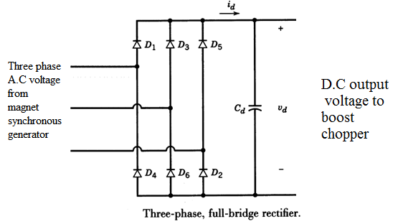

*Figure 1: Circuit of diode rectifier (3 phase)*

There should be a control mechanism for the determination of the switching frequency of MOSFET. This is performed by a pulse width modulation (PWM) signal applied to the gate input of the MOSFET, coming from a controller, either analog or a microcontroller.

The amplitude of the PWM signal does not exceed 5V. The PWM circuit is needed to be isolated from the main power side of high voltage. Therefore, isolation components should be also added to the circuitry.

We may list the pros and cons of “Diode Rectifier and Buck Converter” topology as follows:

1. **Pros**
   1. *i.Output ripples can be controlled by the output L filter.*
   2. *The switching frequency can be controlled easily.*
   3. *The efficiency is relatively high.*
2. **Cons**
   1. *The losses may be high when high frequency switching is used.*
   2. *The complexity is relatively high, by means of the number of components.*
   3. *The cost may be high as a result of part b.*
   4. *One should consider the discontinuous conduction mode of the converter.*

### 1b) Three-Phase Thyristor Rectifier

The “Three-Phase Thyristor Rectifier'' topology requires six thyristors. For each gate of the thyristors, PWM signals with 120 degrees of phase shift are needed. Firing angle is arranged to meet the output voltage requirement.

The circuit of “Three-Phase Thyristor Rectifier'' topology can be seen in the following figure. To play with the average output voltage, there should be a control circuitry for gate signals and firing angles.

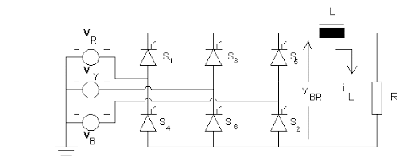

*Figure 2: Circuit of full bridge thyristor rectifier (3 phase)*

The most attractive part of this topology is to achieve desired negligible ripple without any buck/boost converter or capacitor in the DC side. The vital disadvantage of this topology is some kind of synchronization problem. The controller has to be in phase with the AC input part and this requirement makes the controller much more complex with respect to the previous one.

In addition, the resulting power factor is smaller for low voltage levels because of the delay presented in the firing angle.

We may list the pros and cons of “Three-Phase Thyristor Rectifier” topology as follows:

1. **Pros**
2. *Output ripples are lower.*
3. *No need for output LC filtering.*
4. *Output voltage is relatively high.*
5. *The efficiency is relatively high.*
6. **Cons**
7. *Need for a much complicated control circuit for synchronization.*
8. *Low power and discrete power factor.*

### 2) Decision & Design Considerations

The “Power Quality” group decides upon the topology of “Diode Rectifier and Buck Converter for the following reasons:

* The available components in the market are much more diverse.
* The frequency range is much broader. So the output ripple can be adjusted more precisely.
* Relatively cheap if we sacrifice from the low output ripple.
* For high duty cycle values, which may be the case in our project, it is more efficient.

# ANALYTICAL CALCULATIONS

The analytical calculations of the circuit begin with the simple analysis of the buck converter. At first, the duty cycle that needed to operate the converter is calculated. It’s seen that with the variation of input voltage, the duty cycle also changes in specific range. 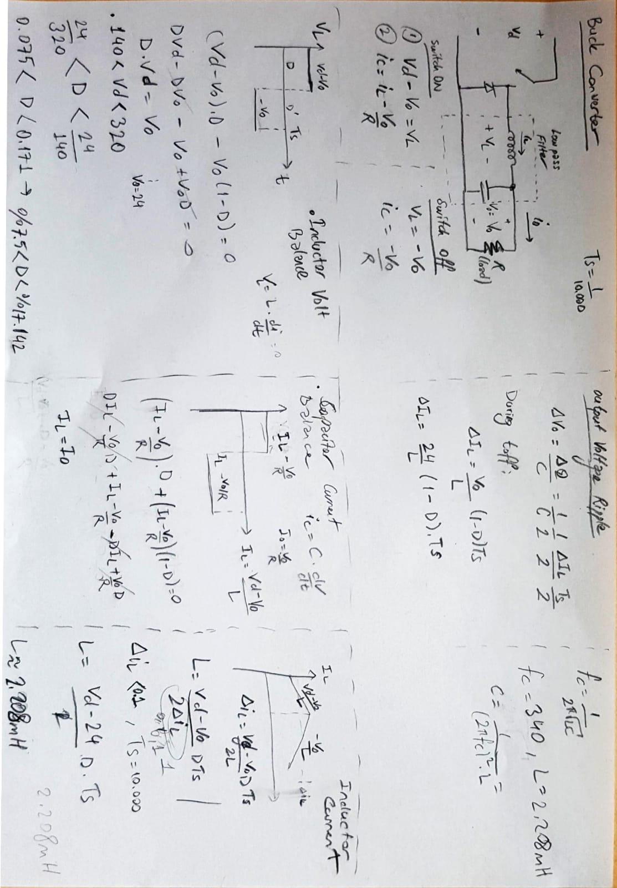

Figure 3: Initial analysis of buck converter

After initial analysis, the inductor and capacitance value of the circuit is calculated in MATLAB as given below.

Vout = 24;

Vin = 300; %It will be in a range e.g. 150 to 330V

i_out = 2;

fs = 50000; %switching frequency

fc = 339; %Corner frequency for LC filter

delta_i = 0.2*i_out; %Desired inductor ripple current

delta_Vo = 0.05; %Desired peak to peak output voltage

D = Vout/Vin; %Duty cycle will also be in a range due to Vin variance

L = Vout*(1-D)/(fs*delta_i); %Inductor sizing

C = 1/(((2*pi*fc)^2)*L); %Capacitor sizing related to corner frequency

% C = delta_i/(8*fs*delta_Vo); %Capacitor sizing

Diode_size = i_out*(1-D); %V30K45, shotky

# COMPONENT SELECTION

We selected the components of rectifiers, capacitors, inductors, resistors and MOSFETs as follows:

### SMD Bridge Rectifiers: Z4DGP406L-HF [1]

The specification of the bridge rectifiers is shown in the table below. The price of this component is 1.03USD. We use 2 of them. Total price is 2.06USD.

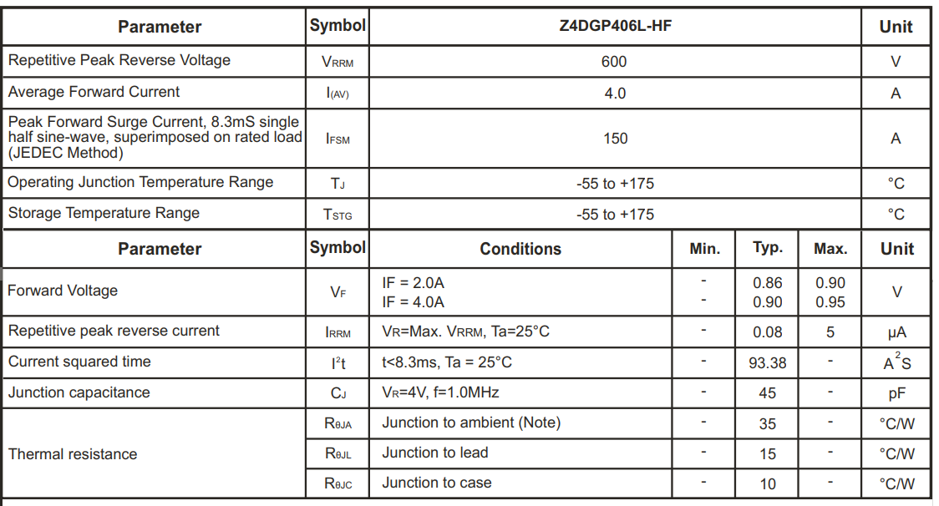

*Table 1: The Technical Specification of the Bridge Rectifier*

### Buck-Capacitor: EEE-FP1V220AR [2]

The specification of the buck capacitor is shown in the table below. The price of this component is 0.43USD. We use 1 of them. Total price is 0.43USD.

|  |  |
| --- | --- |
| Body shape | Surface mount type (vertical mount style) |
| Polarity type | Polar |
| Rated voltage (V) | 35 |
| Capacitance (µF) | 22 |
| Tolerance on capacitance (%) | -40 |
| Tangent of loss angle (max.) | 0.12 |
| Leakage current (max.) (µA) | 7.Tem |
| Category temperature range (°C) | -160 |

*Table 2: The Technical Specification of the Buck Capacitor*

### Rectifier-Out Capacitor (DC Link Capacitor): UVZ2G221MRD [3]

The specification of the DC link capacitor is shown in the table below. The price of this component is 4.23USD. We use 1 of them. Total price is 4.23USD.

|  |  |
| --- | --- |
| Tolerance | ±20% |
| Lifetime @ Temp. | 1000 Hrs @ 105°C |
| Operating Temperature | -40°C ~ 105°C |
| Capacitance | 220µF |
| Voltage - Rated | 400V |
| Ripple Current @ Low Frequency | 660mA @ 120Hz |
| Ripple Current @ High Frequency | 1.056A @ 10kHz |

*Table 3: The Technical Specification of the Rectifier-Out Capacitor*

### Current Measurement Resistor: PE0603DRF570R01L [4]

The specification of the current measurement resistor is shown in the table below. The price of this component is 0.07USD. We use 1 of them. Total price is 0.07USD

|  |  |
| --- | --- |
| TYPE | DESCRIPTION |
| Tolerance | ±0.5% |
| Power (Watts) | 0.5W, 1/2W |
| Composition | Metal Foil |
| Temperature Coefficient | ±100ppm/°C |
| Operating Temperature | -55°C ~ 170°C |
| Resistance | 10 mOhms |

*Table 4: The Technical Specification of the Current Measurement Resistor*

### Buck MOSFETs: FDT3N40TF [5]

The specification of the buck MOSFETs is shown in the table below. The price of this component is 0.65USD. We use 2 of them. Total price is 1.30USD.

|  |  |
| --- | --- |
| Technology: | Si |
| Transistor Polarity: | N-Channel |
| Number of Channels: | 1 Channel |
| Vds - Drain-Source Breakdown Voltage: | 400 V |
| Id - Continuous Drain Current: | 2 A |
| Rds On - Drain-Source Resistance: | 2.8 Ohms |
| Vgs - Gate-Source Voltage: | - 30 V, + 30 V |
| Vgs th - Gate-Source Threshold Voltage: | 5 V |
| Qg - Gate Charge: | 4.5 nC |
| Minimum Operating Temperature: | - 55 C |
| Maximum Operating Temperature: | + 150 C |
| Pd - Power Dissipation: | 2 W |
| Channel Mode: | Enhancement |
| Fall Time: | 25 ns |
| Rise Time: | 30 ns |
| Typical Turn-Off and On Delay Time: | 10 ns |

*Table 5: The Technical Specification of the Buck MOSFETs*

### Buck Inductor: 744822222 [6]

The specification of the buck inductor is shown in the table below. The price of this component is 4.43USD. We use 1 of them. Total price is 4.43USD

|  |  |
| --- | --- |
| Inductance: | 2.2 mH |
| Tolerance: | 30% |
| Maximum DC Current: | 2:00 ÖÖ |
| Maximum DC Resistance: | 70 mOhms |
| Minimum Operating Temperature: | - 40 C |
| Maximum Operating Temperature: | + 125 C |

*Table 6: The Technical Specification of the Buck Inductor*

### Controller: LM5117 [7]

The specification of the controller is explained in the PCB Design section and its total price is 6USD.

The **total cost** of the components is:

(1.03x2 + 0.43x1 + 4.23x1 + 0.07x1 + 0.65x2 + 4.43x1 + 6x1) USD = **18.52 USD**

# SIMULATION RESULTS

The simulation is performed on Matlab Simulink environment by implementing the components and the controller that have been selected in the previous part. The schematic is:

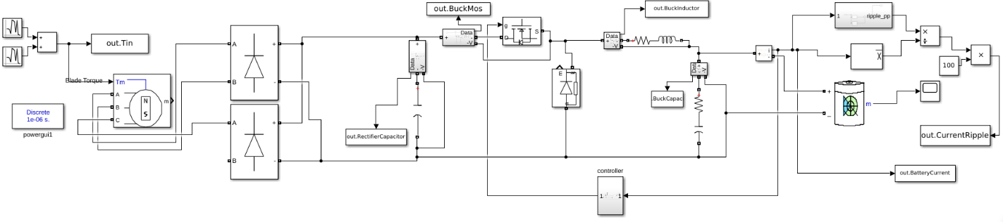

*Figure 4: Diode Rectifier and Buck Converter Schematic*

The controller part of the circuit is shown below:

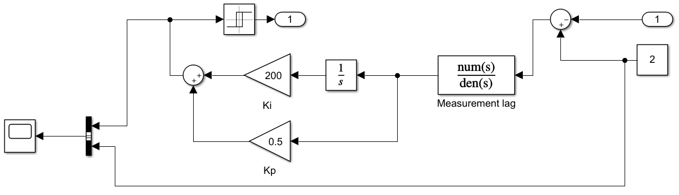

*Figure 5: The Controller Subsystem Schematic*

The simulation includes following components: A Permanent Magnet Synchronous Machine represents the wind turbine generator. The wind is represented by the sum of two normally distributed random numbers that generates torque on the turbine. Then, the resulting phases of the machine are connected to the inputs of the full bridge rectifiers that are represented by universal bridges on simulation. We have a lead-acid battery to store energy from the machine and supply energy to the system. The negative side of the output of the bridge is directly connected to the negative side of the battery. In order to achieve buck conversion, a MOSFET is inserted for the purpose of switching. The drain input of the MOSFET is connected to the positive output of the bridge. So as to achieve the desired output current, the gate signal of MOSFET is fed by an analog hysteresis feedback control with Kp value of 0.5 and Ki value of 200. The control system is fed by an external voltage. As smoothing components, we also add the required filtering elements such as a buck capacitor and inductor, a rectifier-out capacitor.

### Input Torque Waveform

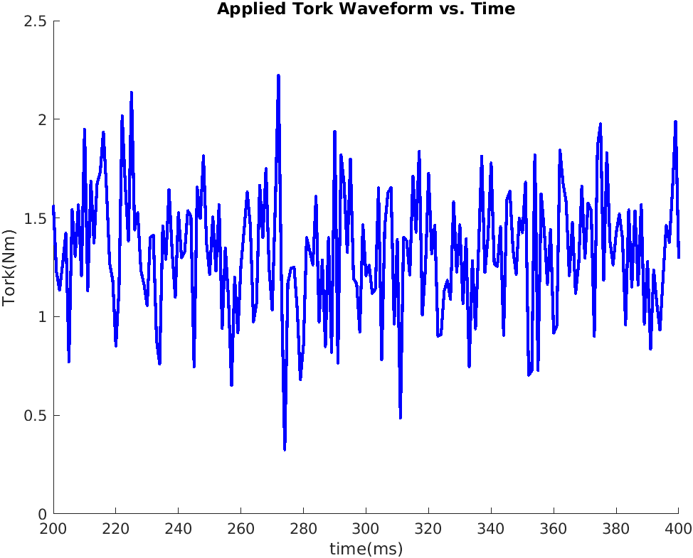

*Figure 6: Random input for wind turbine generator*

Wind turbine is not exposed to fixed power, its mechanical input changing with air conditioning. As seen in the figure, random input applied for our design to see our device's quality in changing voltage level.

### Bridge Rectifier Output Voltage

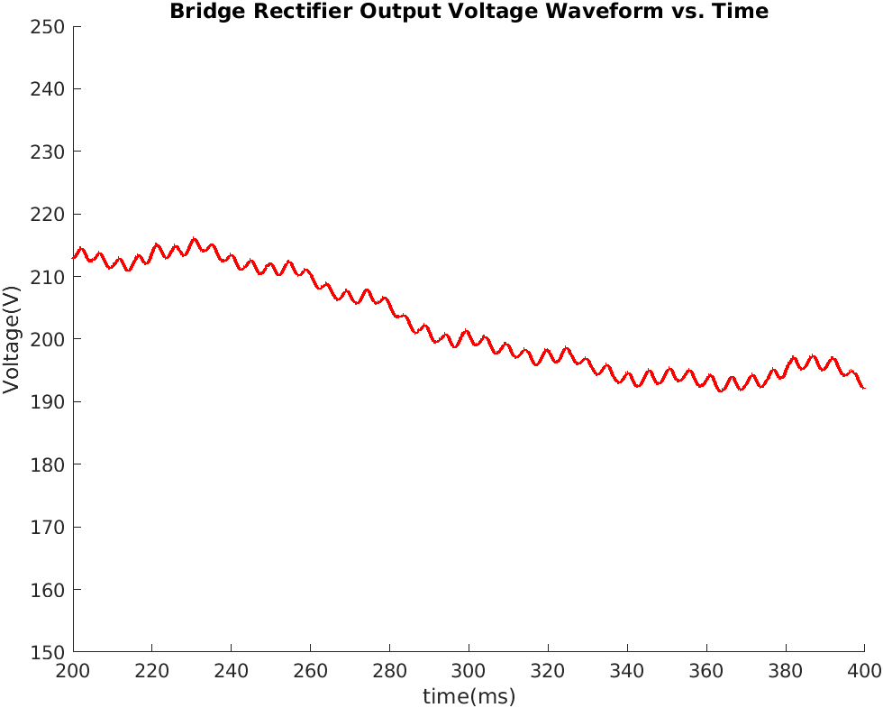

*Figure 7: 3 Phase Bridge Diode Rectifier Output Waveform*

After rectification of varying input voltage, the dc voltage is obtained on the dc link capacitor. This voltage still varies between 190 to 220V. The buck converter side of the circuit is needed to implement to have constant current at the output. To achieve that, the duty cycle of the buck’s mosfet should be arranged with the selected controller.

### Inductor Current Waveform

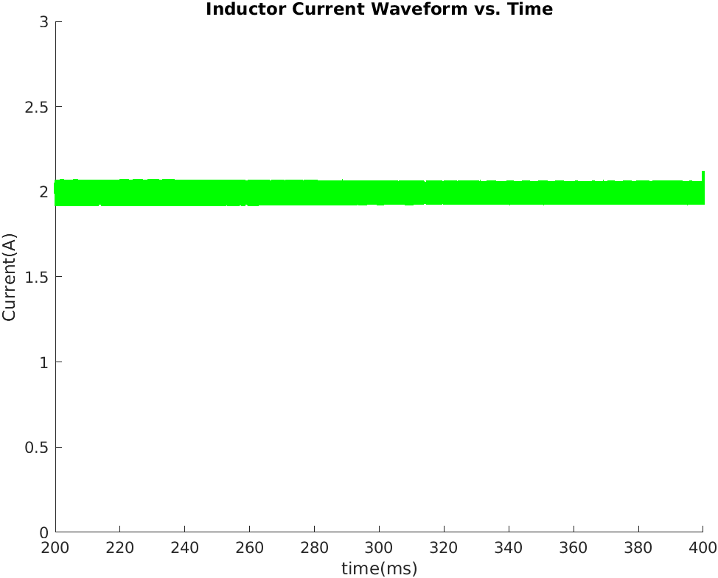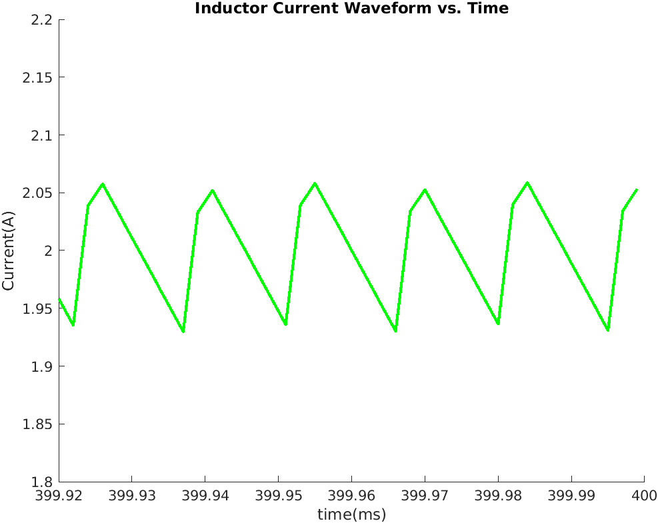

*Figure 8: Inductor Current Waveform*

We have low voltage ripple so filter capacitor current is small and inductor current close to the output current. Our model has a 2.2mH inductance for step down voltage from 300 V to 24 V so it has a small duty cycle and current increase faster than current decrease. Its ripple is smaller than 400mA when changing input voltage applied.

### Mosfet Voltage Waveform

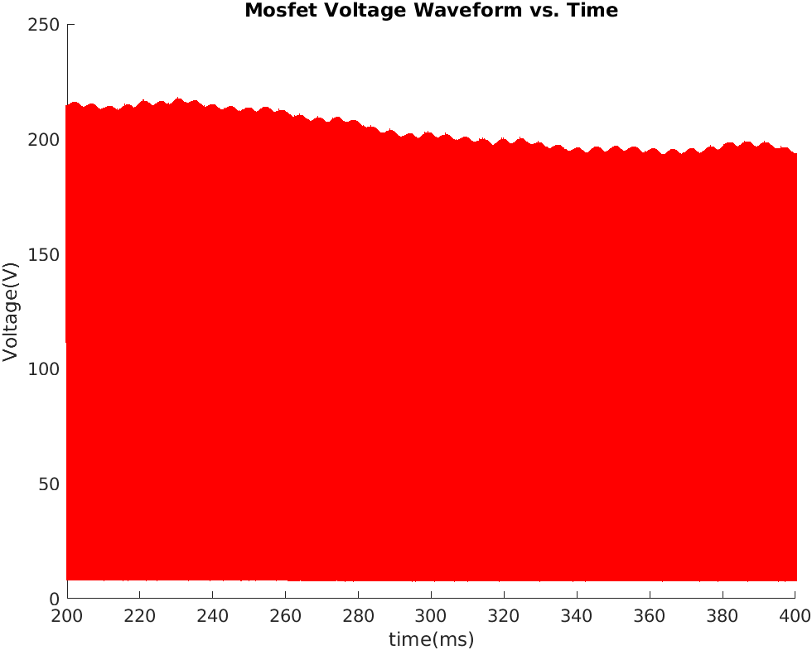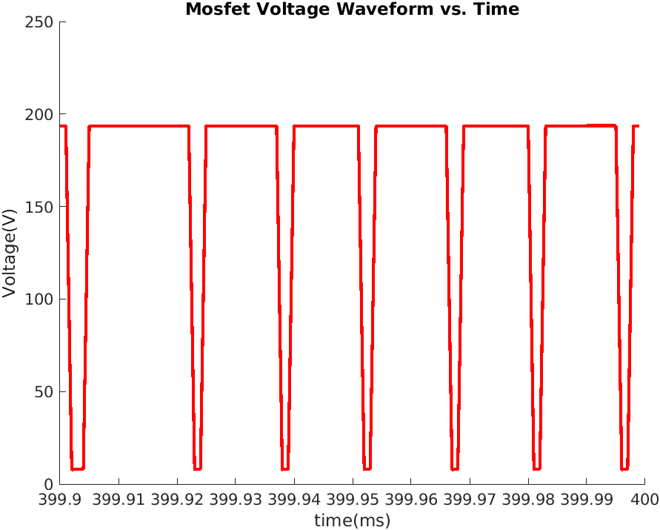

*Figure 9: Buck Converter switching Mosfet Waveform*

Mosfet voltage equal to bridge rectifier output when it is off as seen in figures. When control signal applied mosfet operates in saturation region and its voltage reduces to Vf.

### Buck Converter Voltage and Current Waveform

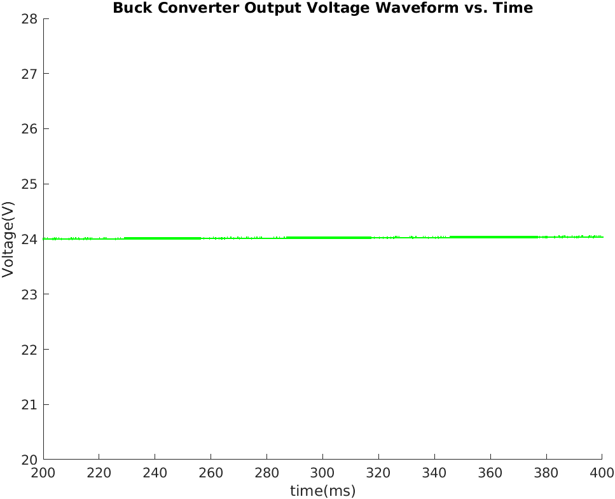

*Figure 10: Buck Converter Output Voltage Waveform*

Since our buck converters output voltage directly connected to the battery, output voltage level is so close to battery nominal voltage and it does not have high voltage ripple as seen in the figure.

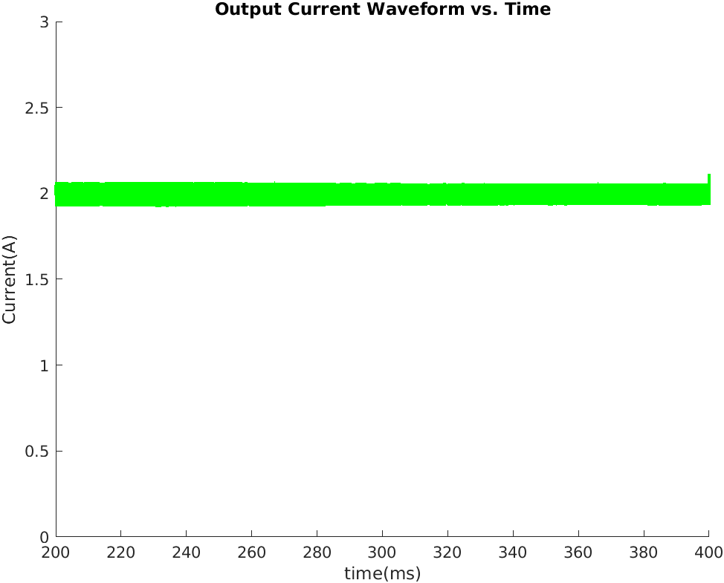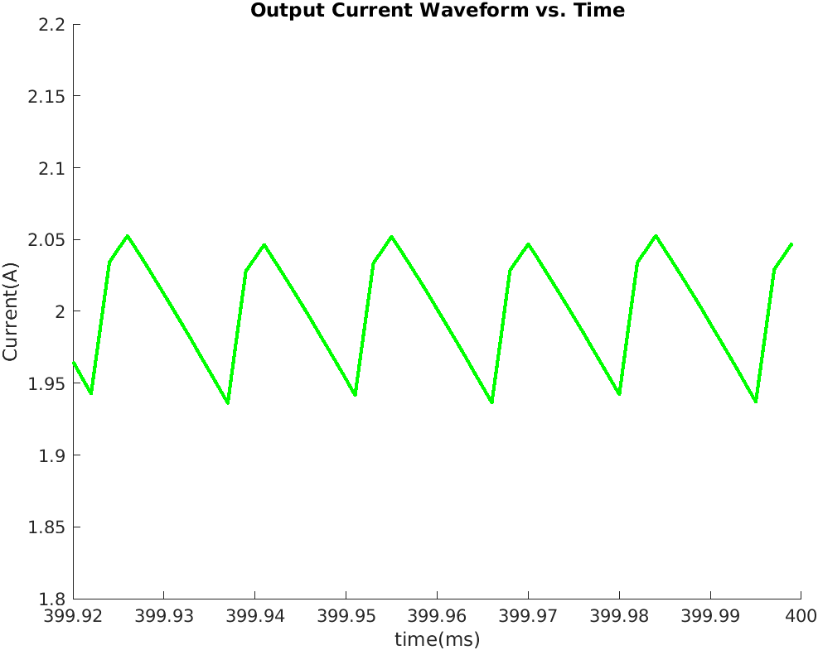

*Figure 11: Buck Converter Output Current Waveform*

One of the important conditions for this term project is to keep current ripple lower than %20 of average current. As seen in the figure output current ripple is around 100mA which is the desired value for the designed circuit.

# PCB DESIGN

The simulated circuit for the term project is implemented on Altium Designer. The selected components are implemented in the Altium library. The schematics of the circuit is given in this section. However, while the circuit is implemented, we encountered undesired problems. The controller couldn't be implemented completely. Moreover , rectifier diodes’ footprints are also missing for this part. Because of that, the PCB design for the project could not be completed.

In simulation, the control method of the circuit is held by the PI controller. For real application, we use an IC controller to have constant current at the output. To do so, LM5117 controller is selected.

To use LM5117, detail specification for each connection of IC is calculated according to application notes of the component. As ‘’Power Quality’’ group, we still have struggles about the controller whether it is selected correctly or not. Because of that, a typical application for constant current and voltage regulation, pin functions, and absolute ratings are given to have better understanding on the device.

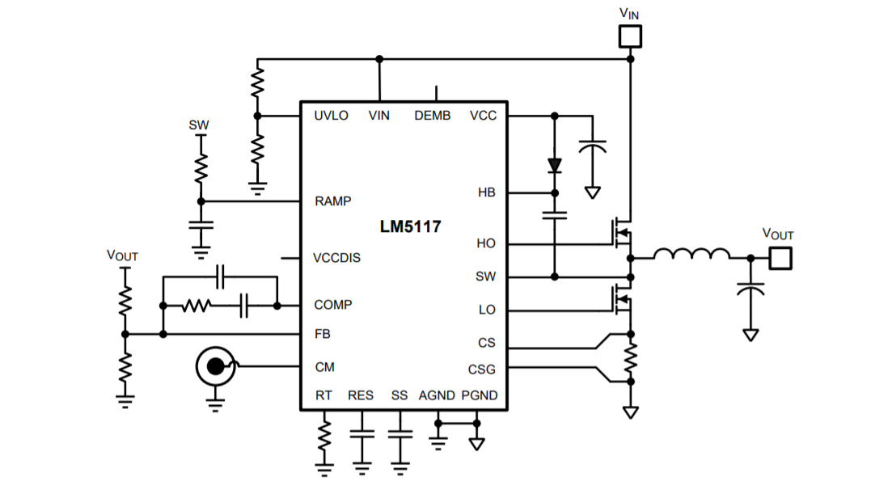

Figure 12: Typical application of LM5117

The typical application is given to understand the implementation of LM5117. In application notes of TI, the controller can be used for constant current and constant voltage method. In the figure below, the current and voltage control method is given for output current as 2A and output voltage as 5V. For our application, the calculations are trying to be done for 2A output current and 24V output voltage.

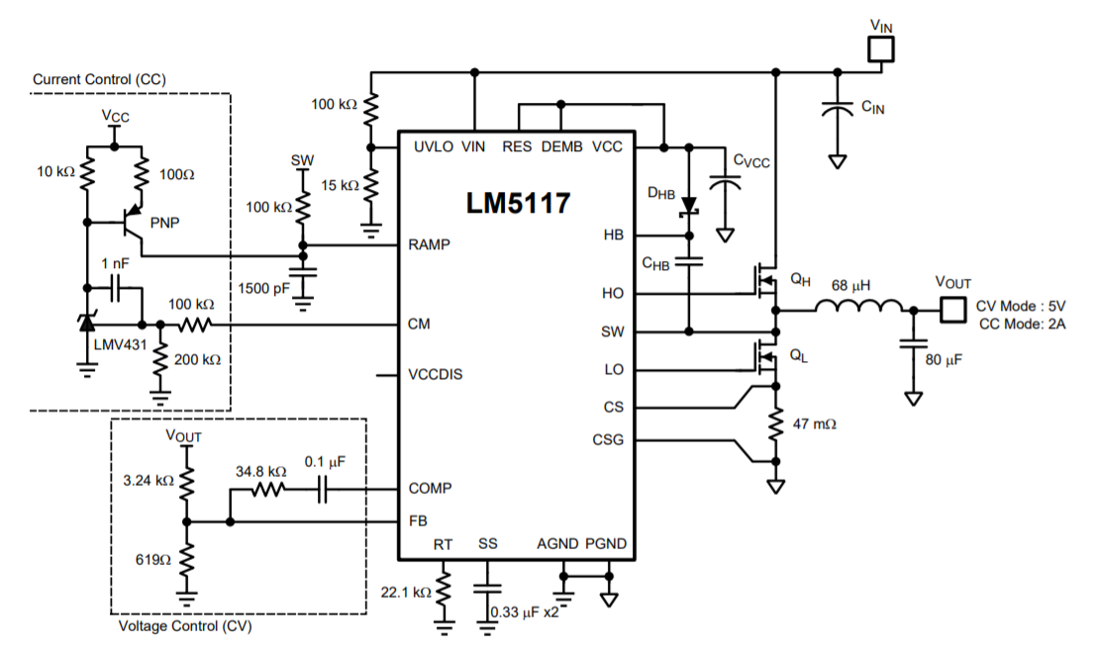

Figure 13: Constant Voltage Regulator with Accurate Current Limit

The pin functions of the controller:

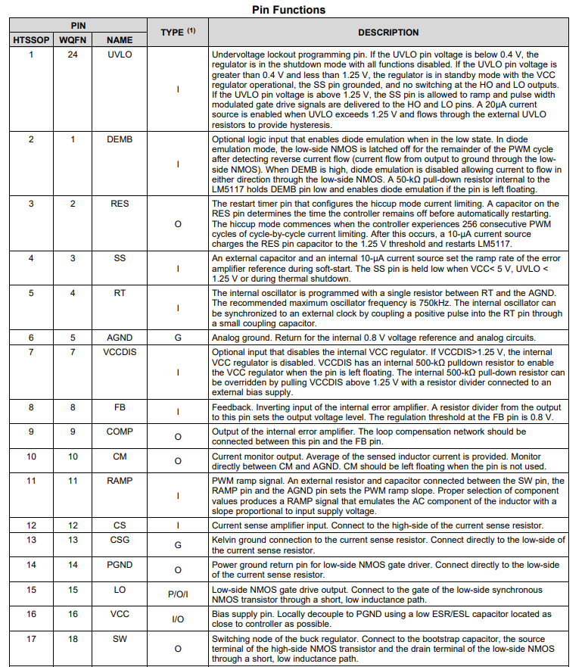

Figure 14: Pin functions of LM5117

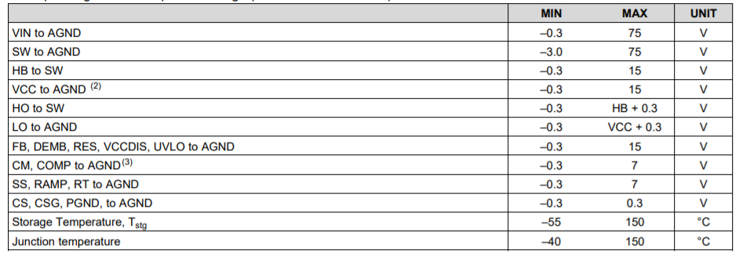

Figure 15: Absolute ratings of LM5117

Detailed Design Procedure for LM5117 is:

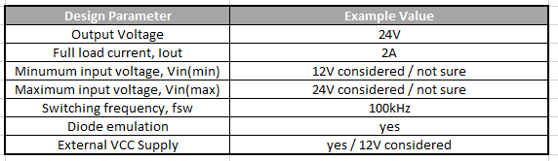

Figure 16: Detailed Design Procedure for LM5117

From the application notes of the controller, desired parameters are taken. For this controller, there is too much to consider selecting the components. Because we are not sure to continue with this controller, the circuit is only implemented according to application values. However, these considerations are tried to be held to have an understanding of the controller.

After trying to select desired parameters for the controller, the circuit is built in Altium schematics. The footprint of each selected component is implemented in the Altium library. The circuit has three parts;

* Rectifier circuit
* Buck Converter
* Current Control

In the rectifier circuit, the rectifier diodes and dc link capacitor are implemented. Input of this circuit is taken by a 4 pos pluggable terminal. This terminal is considered to get input voltage from synchron machine.

In the buck converter schematic, the controller and the buck converter is built. Different from simulation of the project, two synchron MOSFET is used. Implementation of the controller is not fully completed.

In the current control schematic, the logic to have constant current is tried to be applied. We still have struggles about to have the exact values of resistive and capacitive elements for this method.

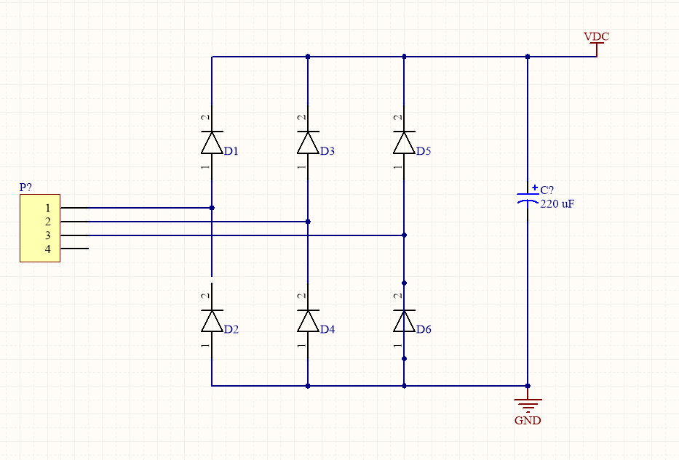

Figure 17 : Rectifier circuit schematic

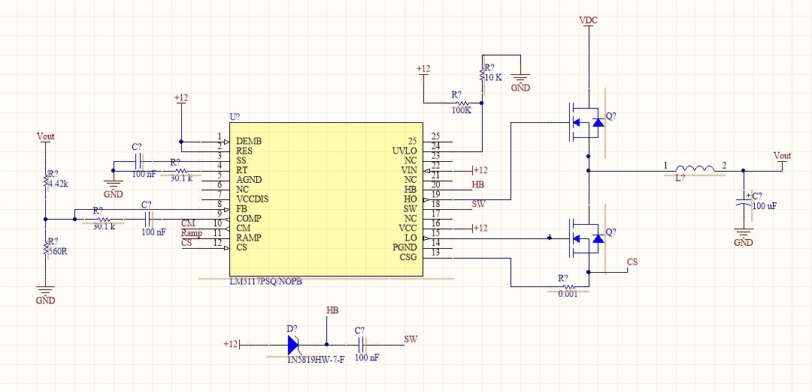

Figure 18: Buck Converter Schematic

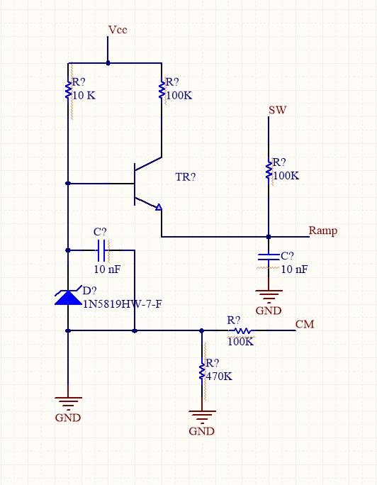

Figure 19: Current Control Schematic

As it mentioned, the pcb design of the circuit couldn’t be finished. Problems encountered while trying to update schematic to pcb is given below.

To be handled;

* Selection of the controller should be done according to given feedback.
* Power ports should communicate between sheets.
* Compile problems should be understood.
* Missing footprint of 400V rectifier diodes should be added.

# CONCLUSION

For the project to regulate the incoming power from the wind turbine generator to feed the battery, a three-phase full-bridge diode rectifier and buck converter circuit is implemented. Analytical calculations of the circuit are measured and its simulations are analyzed in the MATLAB environment. Along with the calculations and simulation, the needed materials are selected in the market. After these progress, the project is tried to implement for real life application. Its schematics are created in Altium Designer. For the pcb design, the project team encountered difficulties to be handled.

# REFERENCES

[1]<https://www.digikey.com/en/products/detail/comchip-technology/Z4DGP406L-HF/4386624>

[2]<https://www.digikey.com/en/products/detail/panasonic-electronic-components/EEE-FP1V220AR/1701004>

[3]<https://www.digikey.com/en/products/detail/nichicon/UVZ2G221MRD/589194>

[4]<https://www.digikey.com/en/products/detail/yageo/PE0603DRF570R01L/5913781>

[5]<https://www.mouser.com.tr/ProductDetail/ON-Semiconductor-Fairchild/FDT3N40TF/?qs=%2Fha2pyFaduiyEk53MxuFExrnikJu3q6flJ%252B5sv%2FExVw%3D>

[6]<https://www.mouser.com.tr/ProductDetail/Wurth-Elektronik/744822222/?qs=sGAEpiMZZMv126LJFLh8yyIZIOICTdvmT6YHDAzFjvY%3D>

[7]<https://www.ti.com/lit/ds/symlink/lm5117.pdf?ts=1608837436095>